
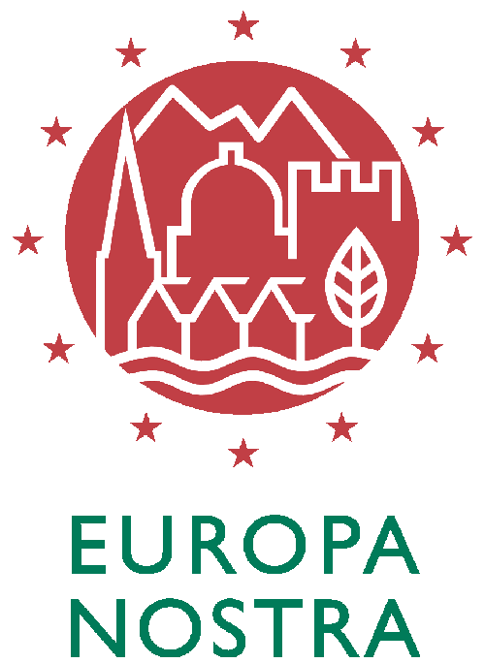
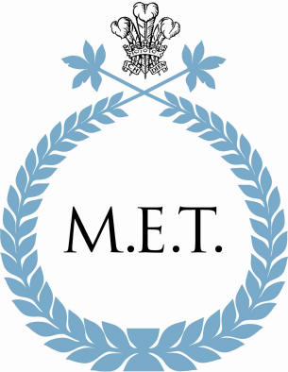

26 April 2007

PRESS RELEASE

The European Commission and Europa Nostra have awarded The Mihai Eminescu Trust First Prize for Dedicated Service to Heritage Conservation. This uniquely prestigious award honours the MET's continued work in repairing and restoring historic buildings, training craftsmen and revitalising the social and economic life of the Saxon villages of Transylvania.

The citation recognises the Trust as having achieved "more than any other organisation for the preservation of the Saxon heritage of Transylvania, a treasure of unique European value".

The prize-giving ceremony will be held in Stockholm on 8 June 2007 in the presence of Their Majesties the King and Queen of Sweden.

For further information go to www.europanostra.org/awards_2006.html or contact Luminita Holban tel. +44 20 72297619, email lholban@mihaieminescutrust.org

The Mihai Eminescu Trust is a British – Romanian charity dedicated to the preservation of the cultural and natural heritage of the Saxon villages of Transylvania. Mass emigration of the Saxon inhabitants to Germany in the early 1990s threatened many villages in Transylvania with depopulation and total abandonment. Some villages have World Heritage status, yet hundreds of inestimable historic buildings are crumbling away because of neglect and lack of resources. For over eight years, the Mihai Eminescu Trust (MET) has been trying - through its innovative Whole Village Project - to preserve the historical landscape of the region, while catalysing the development of a sustainable rural economy. By saving over 300 historic buildings in 15 villages and training over 100 local craftsmen in traditional building skills, the MET has kept Saxon heritage alive, while also assisting local villagers in setting up income-generating activities and small business ventures in guesthouse tourism, building conservation, organic agriculture and traditional crafts.

Europa Nostra, the pan-European Federation for Heritage, is the representative platform of over 230 heritage NGOs active throughout Europe. It is the voice of this vast movement of European civil society active in the field of heritage towards international bodies concerned, in particular the European Union Institutions, the Council of Europe and UNESCO. Europa Nostra is dedicated to putting heritage and its benefits in the mainstream of public consciousness and to making heritage a priority for public policies both at European and national levels. Its specific objectives are to promote, at a European level, high standards of quality in the fields of heritage conservation, architecture, urban and rural planning and to advocate a balanced and sustainable development of urban and rural, built and natural environment. Europa Nostra supports national and international campaigns for the preservation and rescue of Europe’s heritage at risk. It encourages exemplary initiatives in favour of the conservation and enhancement of cultural heritage by recognising outstanding heritage achievements, in particular through the running of the European Union Prize for Cultural Heritage / Europa Nostra Awards.

